3D Animation-Shrine above the clouds（云巅琼楼）

1.’What if’ Questions

What if the world is upside-down?

What if a house can float in the air?

What if a palace is built underwater?

What if a town is built on a giant tree?

What if we manage to live on Mars?

2.Robot Task

With reference to:

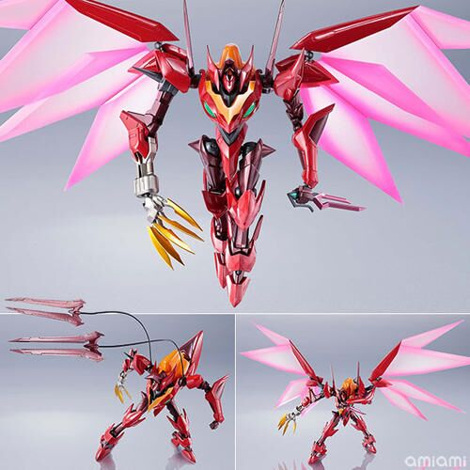

I did a simplified version like this:

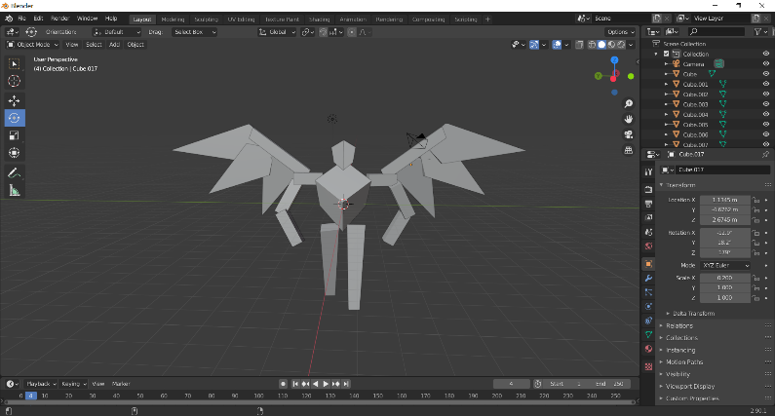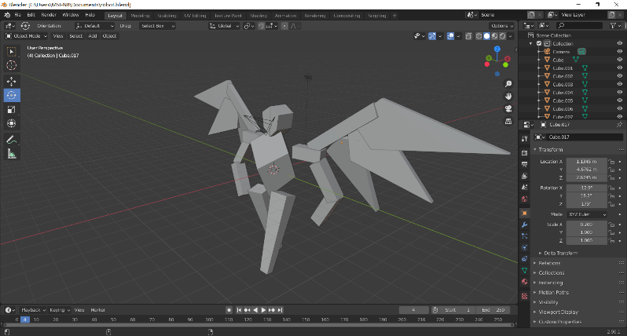

3.Moodboard Research

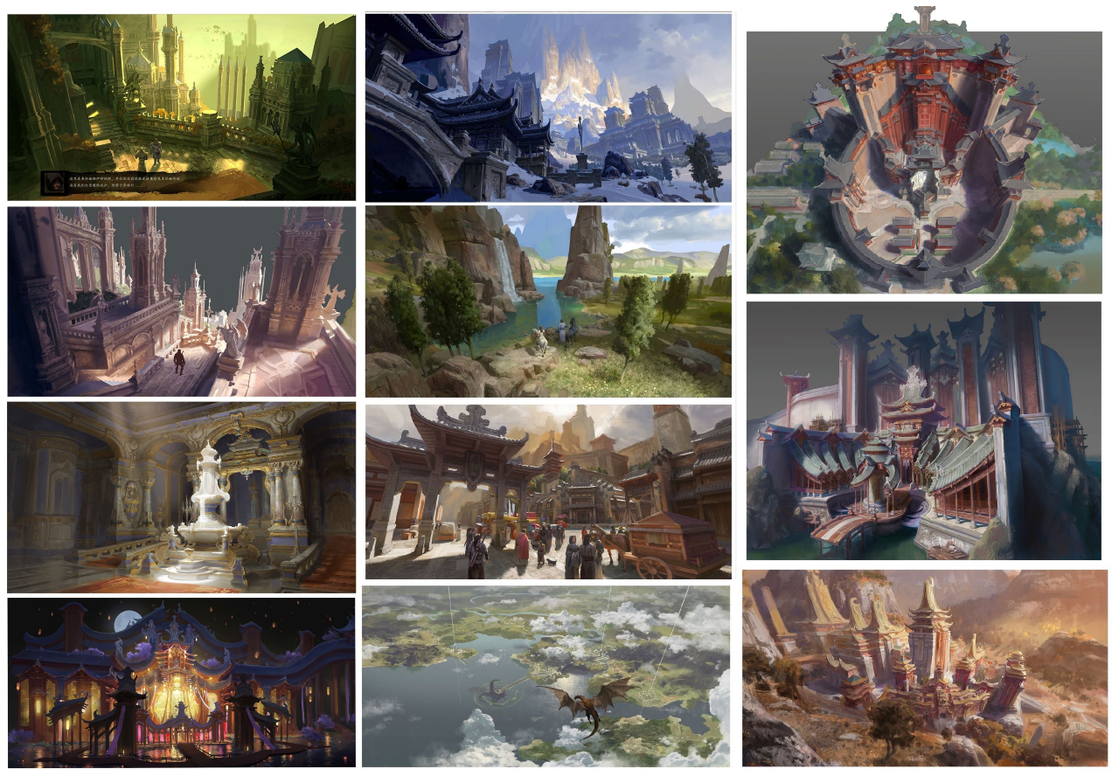Environment art that I like.

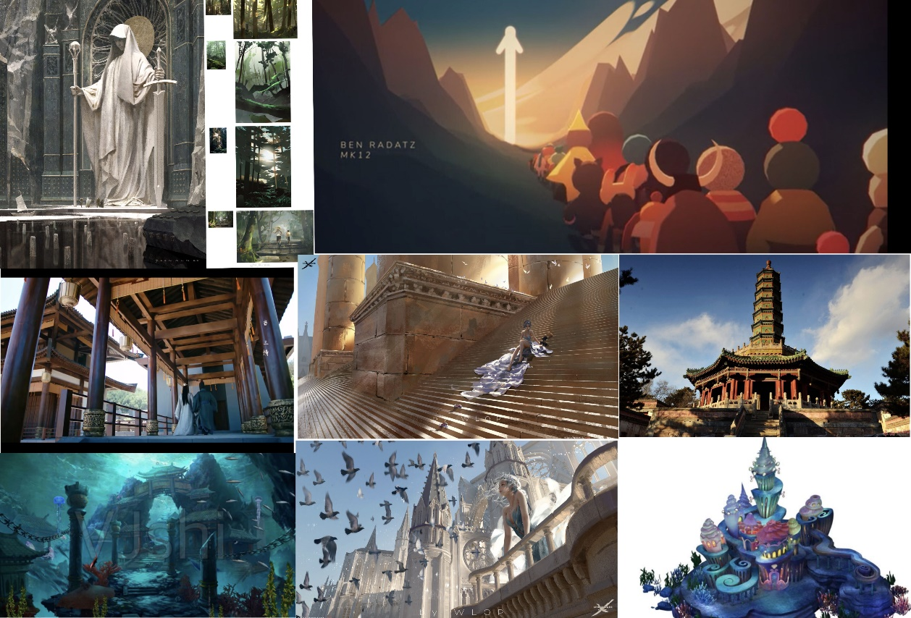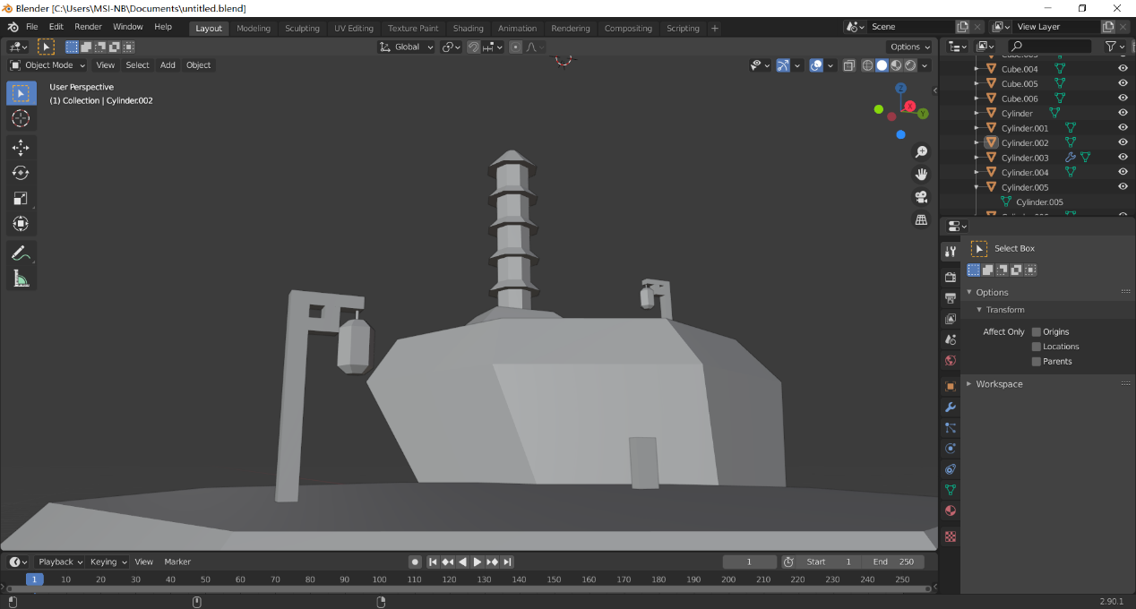

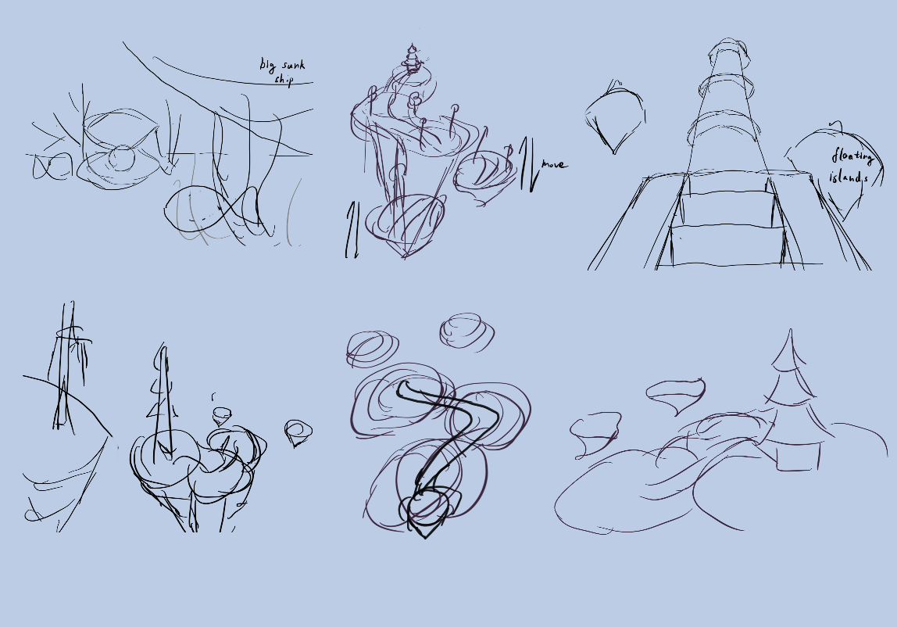3. Thumbnail Drawings

Thumbnails 1 and 2 are 2 different scenes, I love the second scene and drew it from different perspectives as in thumbnails 3-6.

4.Concept Drawing

Arrows indicate the direction of move of the objects.

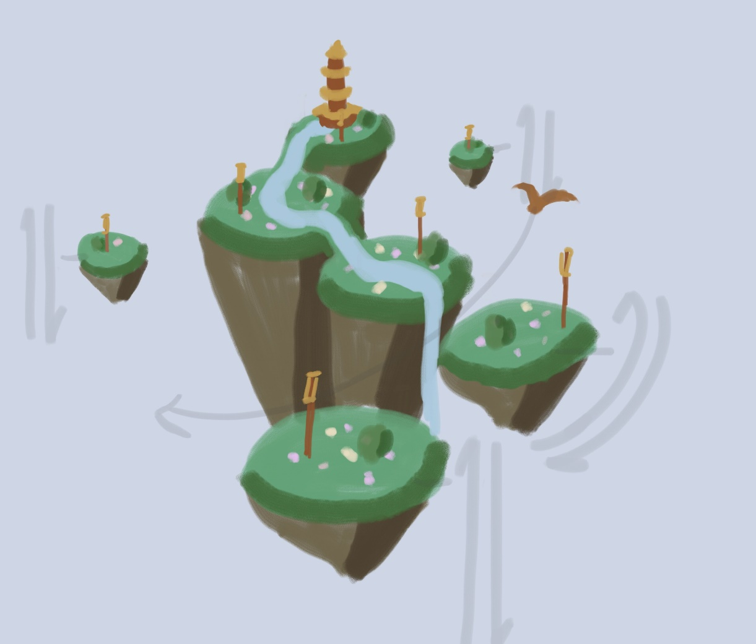

5.Modelling

